
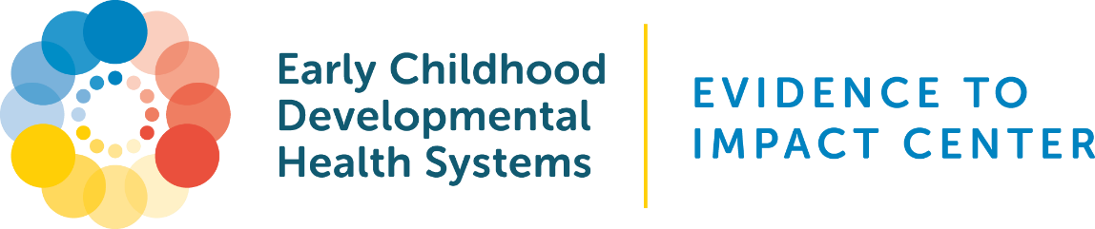

Family Story Consent Form Template

This template consent form was adapted by the Early Childhood Developmental Health Systems (ECDHS): Evidence to Impact Center for programs to use when collecting family stories. When using this document, organizations should tailor content in the bracketed placeholders and remove or revise other areas as needed. Please delete this cover page in full before sharing the document with family leaders.

Funding Acknowledgement: The Early Childhood Developmental Health Systems (ECDHS): Evidence to Impact Center was made possible through the support of the Health Resources and Services Administration (HRSA) of the U.S. Department of Health and Human Services (HHS) as part of an award totaling $4,740,000 with 0% financed from non-governmental sources. The contents are those of the authors and do not necessarily represent the official views of, nor an endorsement by, HRSA, HHS, or the U.S. Government. For more information, please visit HRSA.gov.

[Title of Project or Activity]
Consent and Release Form
By signing below, you agree to the following terms and conditions of this agreement and state that you fully understand your rights as a storyteller.
Purpose of [Insert title of project or activity]
[Write a clear and informative purpose statement here. Below is an example:
The purpose of this story is to empower families to share their experiences with different parts of the system that impact their lives. It is important for policymakers and political leaders to hear your stories. By keeping a large, ongoing collection of stories on a variety of topics that impact families, we can provide stories that relate to a variety of settings and circumstances.]
Intended Audience
The intended audiences for the [insert title of project or activity] and stories include [list audiences, such as policymakers, partners, and individuals who access your website].
Your Rights
- You have the right to access and update your story.
- You have the right to change your mind and revoke consent. If you inform us, we will not use your story again in the future. However, we may not be able to withdraw content or materials that have already been published.
- If you wish for your story to stop being used or if you have any questions or comments about how your story is being used, please contact (insert main contact email).
Frequently Asked Questions (FAQs)
- How will I be identified in the stories?

[Insert your organization name] knows that it can be a vulnerable experience to share your story. When you provide a story, you are given the option to provide your name. However, that is not required. Instead, you can choose to leave that blank and just identify as a person from your location. For example, “I am a mother of two seven-year-old children with autism living in North Carolina.”

If you share your story through a survey form, you do not need to include your name. However, you will be assigned an anonymous identification code that will help us track if you are submitting a new or updated story. Only the information that you agree to share will be shared.

- How will my story be shared?

Stories may be shared on all forms of media now known or hereafter developed, including, but not limited to:
- Social media posts (Facebook, Instagram, LinkedIn, etc)
- Blogs
- [Insert organization name] webpages
- Printed or digital marketing materials
- Content created and distributed by (insert organization name) partners

- What if I want to change my story?

If you have submitted a story and would like to make updates to the story based on your situation, you can do so by [insert contact details or process].

Please sign and date below to confirm that you have read and agreed to the terms stated above.

____________________________________ _____________________
Signature Date

